Part A
Aim:
(1) Local Outlier Factor (LOF)
(2) Cluster based Local Outlier Factor (CBLOF)
(3) Local Density Cluster based Outlier Factor (LDCOF)

Prerequisite: Python, Jupyter IDE and Internet connection

Local Outlier Factor(LOF):

Introduction:
The Local Outlier Factor (LOF) algorithm is an unattended method of detection of anomalies that calculates a local density difference from the neighbouring data point. Samples with a slightly lower density than their neighbours are considered outliers.
The Local Outlier Factor (LOF) algorithm is an unsupervised anomaly detection method which computes the local density deviation of a given data point with respect to its neighbours. It considers as outliers the samples that have a substantially lower density than their neighbors. This example shows how to use LOF for outlier detection which is the default use case of this estimator in scikit-learn. Note that when LOF is used for outlier detection it has no predict, decision_function and score_samples methods.
The number of neighbors considered (parameter n_neighbors) is typically set
1) greater than the minimum number of samples a cluster has to contain, so that other samples can be local outliers relative to this cluster, and
2) smaller than the maximum number of close by samples that can potentially be local outliers. In practice, such information’s are generally not available, and taking n_neighbors=20 appears to work well in general.
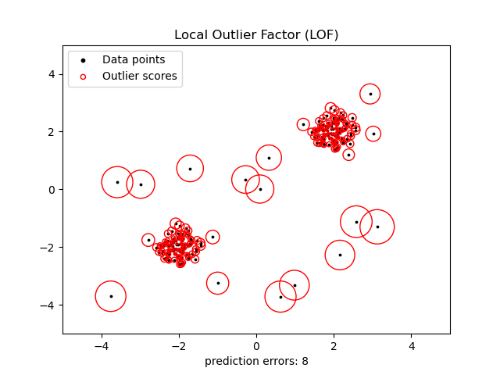

Cluster based Local Outlier Factor (CBLOF)
Introduction:
The local outer factor is based on a principle of local density, where locality is defined by k. An additional variable is used to achieve more consistent outcomes within clubs. The LOF meaning is "reachability distance."

Local Density Cluster based Outlier Factor (LDCOF)
Introduction:
The local density estimation of CBLOF using only the amount of cluster members is controversial. CBLOF is in fact not a local anomaly detection method any more since the density of the cluster is completely neglected. The local density cluster-based outlier factor LDCOF addresses this shortcoming by estimating the clusters’ densities assuming a spherical distribution of the cluster members.

Part B
Code and Output:

Observation & Learning:

Conclusion:

